# Lab 6:

**Serial Communications, USART Module, RS232 Standard**

**Name (Print):** _______REZA SHISHEIE______________________ID___2708062___________  
  
**Give brief answers to the following questions. You can edit this document and insert your answers after each question.**

**Due dates:**

**MW – Wed, Mar 28, beginning of class  
TTH – Tue, Mar 27, beginning of class**

**Circle one: MW or TTH**

1. (1 pt) What word is formed by the following ASCII codes?  
     
   75h – 62h – 69h – 71h – 75h – 69h – 74h – 6Fh – 75h – 73h   
     
   **Ans.**

u – b – i – q – u – i – t – o – u – s = ubiquitous

1. (1 pt) What is “bit banging” ?  
     
   **Ans.**   
   Bit banging is a technique for [serial communications](https://en.wikipedia.org/wiki/Serial_communications) using software instead of dedicated hardware. Software directly sets and [samples](https://en.wikipedia.org/wiki/Sampling_(signal_processing)) the state of pins on the [microcontroller](https://en.wikipedia.org/wiki/Microcontroller), and is responsible for all parameters of the signal: timing, levels, synchronization, etc. In contrast to bit banging, dedicated hardware (such as a [modem](https://en.wikipedia.org/wiki/Modem), [UART](https://en.wikipedia.org/wiki/UART), or [shift register](https://en.wikipedia.org/wiki/Shift_register)) handles these parameters and provides a ([buffered](https://en.wikipedia.org/wiki/Data_buffer)) data interface in other systems, so software is not required to perform signal [demodulation](https://en.wikipedia.org/wiki/Demodulation). Bit banging can be implemented at very low cost, and is used in [embedded systems](https://en.wikipedia.org/wiki/Embedded_systems).
2. (1 pt) Express the decimal number 492710 in binary coded decimal (BCD), binary, and hex.  
     
   **Ans.**  
   492710 = 0100 1001 0010 0111492710 = 1 0011 0011 1111  
     
   492710 = 133F

1. (1 pt) What is a **null modem** RS-232 cable? Is the cable that was supplied in your parts kit for this lab a null modem? How can you test this?  
     
   **Ans.**

* Null modem is a communication method to directly connect two DTEs (computer, terminal, printer, etc.) using an RS-232 serial cable.
* Yes, the cable provided in the kit is null modem
* To tell if your cable is null modem or straight though, you can search the part number at ni.com, the product description will tell if it is null modem. Alternatively you can use a hand held DMM to test continuity on the individual pins of your serial cable. If every pin is electrically connected to the corresponding pin on the other end, i.e.: pin 1 to pin1, pin 2 to pin 2, etc. then the cable is straight through. In addition you can connect 2 and 3 and see if you send something on RX you would receive it on TX

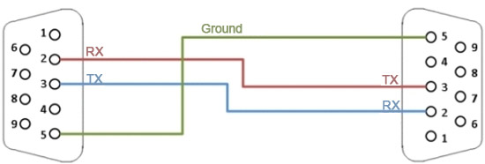

Simple Null Model Cable

1. (1 pt) We learned in class that the RS232 pins 2, 3, and 5 on a DB9 connector are used for receive, transmit, and ground. What are the other pins used for?  
     
   **Ans.**1: Data Carrier Detect 4: Data Terminal Ready  
     
   6: Data Set Ready 7: Request to Send  
     
   8: Clear to Send 9: Ring Indicator
2. (1 pt) What is the difference between the terms **baud rate** (or baud) and **bit rate**.  
     
   **Ans.**The bit rate is a measure of the number of bits that are transmitted per unit of time. The baud rate, which is also known as symbol rate, measures the number of symbols that are transmitted per unit of time. A symbol typically consists of a fixed number of bits depending on what the symbol is defined as(for example 8bit or 9bit data). The baud rate is measured in symbols per second.
3. (1 pt) According to the data sheet, what causes a **framing error**? Which bit (bit number and mnemonic) in which register is set when a framing error occurs?  
     
   **Ans.**   
   Framing error bit FERR (RCSTA<2>) is set if a STOP bit is detected as clear. Bit FERR and the 9th receive bit are buffered the same way as the receive data. Reading the RCREG will load bits RX9D and FERR with new values.

FERR is bit 2 of the RCSTA register and if set it means framing error happened. It can be updated by reading RCREG register and receive next valid byte.

1. (1 pt) What special kind of register is RCREG? What causes an overrun error?  
     
   **Ans.**  
   After sampling the STOP bit, the received data in the RSR is transferred to the RCREG register (if it is empty).After sampling the STOP bit, the received data in the RSR is transferred to the RCREG register (if it is empty).

It is possible for two bytes of data to be received and transferred to the RCREG FIFO and a third byte to begin shifting to the RSR register. On the detection of the STOP bit of the third byte, if the RCREG register is still full, the overrun error bit OERR (RCSTA<1>) will be set.

1. (1 pt) Suppose a PIC with a baud rate of 9681 bps is transmitting to another PIC with a baud rate of 9581 bps. What is the maximum percentage error between the two rates? Will this result in framing errors? Explain your answer.  
     
   **Ans.**Max allowable baud rate error is ±5.3%

Error = (9681 - 9581)/ 9581 = %1.04  
this is less than the maximum allowable baud rate error and thus this does not cause framing error.

1. (1 pt) According to the Guinness Book of World Records, *A la recherche du temps perdu* by Marcel Proust is the world’s longest novel. Suppose the PIC is configured to transmit ASCII text at 19200 baud.

a) How many characters are transmitted per second?  
**Ans.**  
the baud rate is 19200 which means that 19200 symbols are transmitted per second. Assuming each character is an ASCII character, 19200 characters are sent according to this baud rate.

b) At this rate, how many minutes would it take to transmit the world’s longest novel?

**Ans.**   
according to Guinness, this book has 9,609,000 characters:

Time = 9,609,000/19200 = 500 seconds

1. (2 pts) Suppose you have a PIC with *Fosc* = 10 MHz. If BRGH = 1, what value of SPBRG should you use if you want to communicate at 57600 baud? What is the actual baud rate that you will achieve with this value of SPBRG? What is the resulting percent error in your baud rate? Will this cause communication errors? Repeat for BRGH = 0.  
     
   **Ans.**

**BRGH = 1:**

a)SPBRG = F/(16 * Baud Rate) - 1 = 10e6/(16*57600) -1 = 9.85  
  
b) SPBRG = 10 🡪 Baud Rate = 10e6/(16*(10+1)) = 56818.18  
  
c) Error = (56818.18- 57600)/ 57600 = %1.3

d) this is smaller than %5.3 which **does not cause** communication error

**BRGH = 0:**a)SPBRG = F/(64 * Baud Rate) - 1 = 10e6/(64*57600) -1 = 1.71  
  
b) SPBRG = 2 🡪 Baud Rate = 10e6/(64*(2+1)) = 52083.33  
  
c) Error = (52083.33- 57600)/ 57600 = %9.5

d) this is larger than %5.3 which **causes** communication error

1. (1 pt) What is the hex value and the equivalent ASCII character of the W register after the following sequence of instructions?  
     
   movlw “@”  
   addlw “?”  
     
   **Ans.**   
   w = 0x40 (@) + 0x3F (?) = 0x7F (DEL) = 111 111
2. (2 pts) Suppose an RS232 line has noise such that there is a 1.5 % chance of reading a bit value incorrectly. What is the probability of reading **at least** two out of three bit values correctly? Give the answer to six decimal places. (Hint: This is a Binomial Experiment – *k* successes in *n* trials. Note the “at least” in bold.)  
     
   **Ans.**at least 2 means the probability of all 3 is correct + the probability of 2 out of 3 is correct

Incorrect probability : P(a) = 0.015

Correct probability : P(b) = 1 – P(a) = 0.985

P = P(all 3 correct) + P(2 out of 3 correct)

P = TTT + TTF + TFT + FTT = TTT + 3(TTF)

P = (0.985*0.985*0.985) + 3(0.985*0.985*0.015) = 0.999 = %99.9

1. (2 pts) Communication between the PIC and the MAX202 transceiver is achieved using the TTL protocol which uses +5 V for logic 1, and 0 V for logic 0. Communication between the MAX202 transceiver and the PC is achieved using the RS232 protocol. According to the MAX202 data sheet from Maxim Integrated Inc, what are the voltage levels corresponding to logic 1 and logic 0 for the RS232 transmitter output and the RS232 receiver input ? What is the maximum data rate?  
     
    (Hint: You should list two voltage levels for the RS232 input and two voltage levels for the RS232 output. The current RS232 standard is referred to as the EIA/TIA-232E specification in the data sheet.)   
   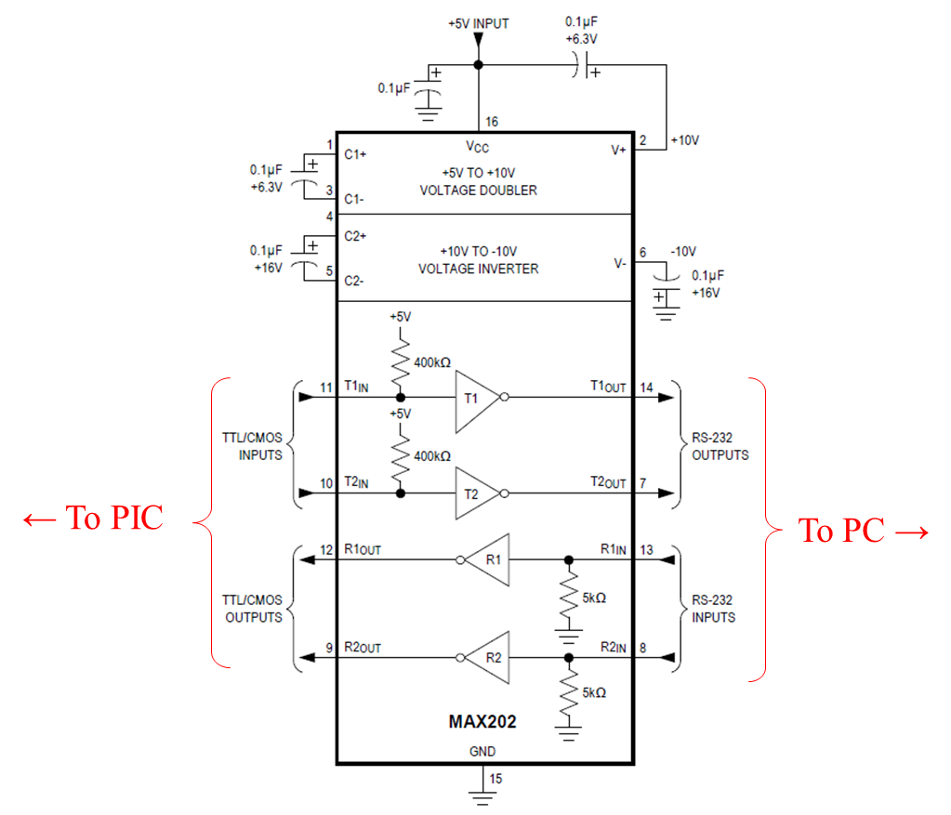  
     
   **Ans.**   
     
   RS232 Driver Output Voltage: 0 Level: -5

RS232 Driver Output Voltage: 1 Level: 5  
  
RS232 Receiver Input Voltage: 0 Level: 0.4

RS232 Receiver Input Voltage: 1 Level: 3.5  
  
Maximum data rate = 120 kbit/s

1. (10 pts) Create a new project based on lab06a.asm called lab06a_modified. Modify the program so that each time a button on the breadboard is pressed, a counter in the PIC increments and the value of the counter is transmitted to, and displayed by, the PC serial port program on the PC. The program should initially display “0” on the PC, and increment through the digits until “9” is displayed. After “9” is displayed, the next time the button is pushed “0” should displayed, and then the sequence should repeat. Demonstrate and explain the program to the instructor or TA.

**Student Name** ____________________________________________________________

**Instructor/TA signature** _________________________________ **Date**_____________

1. (5 pts) Demonstrate lab06b to the instructor or TA and explain how the code works.

**Instructor/TA signature** _________________________________ **Date**_____________